CHAPTER 13: GUI PROGRAMMING USING TKINTER
TOPICS COVERED:
13.1 WHAT IS TKINTER?
13.2 TKINTER LAYOUT MANAGERS
13.3 TKINTER WIDGETS
13.4 TKINTER RELIEF ATTRIBUTES
13.5 SAMPLE CODES FOR CREATING GUI

13.1 WHAT IS TKINTER
- Tkinter is standard GUI library available in python which serves as an standard interface to Tk, a simple gui toolkit.
- Tkinter GUI applications are often powered by object oriented programming that is commonly known as event – driven, means the program responds to actions taken by the user.
- In some linux distributions like ubuntu and debian, tkinter module is packaged separately to the rest of python and must be installed separately.
- In python 2 series, gui module generally used was Tkinter
- In python 3 series, gui module used frequently is tkinter [ use python 3.6 & greater series for gui creation]
13.2 TKINTER LAYOUT MANAGERS
- There are three types of layout managers available in python,
  - Pack manager
  - Grid manager
  - Place manager
BENEFITS:
- Arrange widgets on the screen.
- Register widgets with the parent windowing system.
- Managing the widgets display in system.
PACK MANAGER:
- This pack manager is mainly used to place the position of the widget in the parent window instead of declaring the widget precisely.
- This manager is limited when compared with grid and place managers.
- This manager also allows the user to give padding and spacing with fill attributes in it.
PLACE MANAGER:
- This place manager allows the user to explicitly set the location and position of a widget in parent window.
- It can access through place method and applied to almost all standard widgets.
- It can be assigned position in either absolute terms or relative to another window.
GRID MANAGER:
- This manager is acting like a two dimensional table like structure and much complex than pack and place but more useful in general applications.
- The position of a widget will be stored in a two dimensional table using row number and column number. Widgets with same column numbers and different row numbers can be placed above or below each other.
- This manager allows the user to place the widget in the exact location where he wants to place it in the parent window.
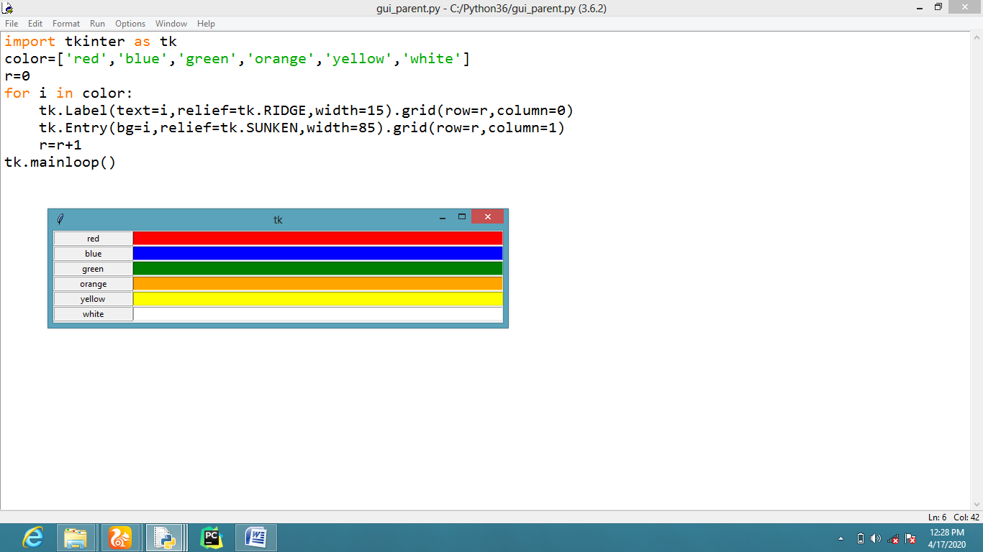
13.3 TKINTER WIDGETS
- Tkinter provides us with different elements which can be used to develop a user interface application with buttons, frames, labels and menu bar with some internal display areas.
- Usually these elements are widgets in tkinter module of python.
- Tkinter widgets are like toolkit for crating effective user interface applications with minimized code.
- There are many different widget classes built into tkinter – there are,
- Frame - is a container widget which is placed inside a window, which can have its own border and background – it is used to group related widgets together in an application’s layout.
- Canvas - is a widget for drawing graphics. In advanced usage, it can also be used to create custom widgets – because we can draw anything we like inside it, and make it interactive.
- Text - displays formatted text, which can be editable and can have embedded images.
- Button - usually maps directly onto a user action – when the user clicks on a button, something should happen.
- Label - is a simple widget which displays a short piece of text or an image, but usually isn’t interactive.
- Message - is similar to a Label, but is designed for longer bodies of text which need to be wrapped.
- Scrollbar - allows the user to scroll through content which is too large to be visible all at once.
- Checkbutton – allows the user to choose the number of attributes.
- Radiobutton – allows the user to select a choice like options.
- Listbox – used to list the available choices
- Entry – used to give input values at run time
- Menu and Menubutton are used to create pull-down menus.
- The above mentioned widgets are frequently used in python to create effective Graphical user interface with complete ownership control over widgets position.

13.4 TKINTER RELIEF ATTRIBUTES
- Relief attributes in tkinter module is used and configured along with frame widget so that the user can apply any type of border around the frame.
- To apply the border effects, user must set the borderwidth attribute to a value greater than one.
- Relief attributes are,
  - FLAT
  - SUNKEN
  - RAISED
  - GROOVE
  - RIDGE
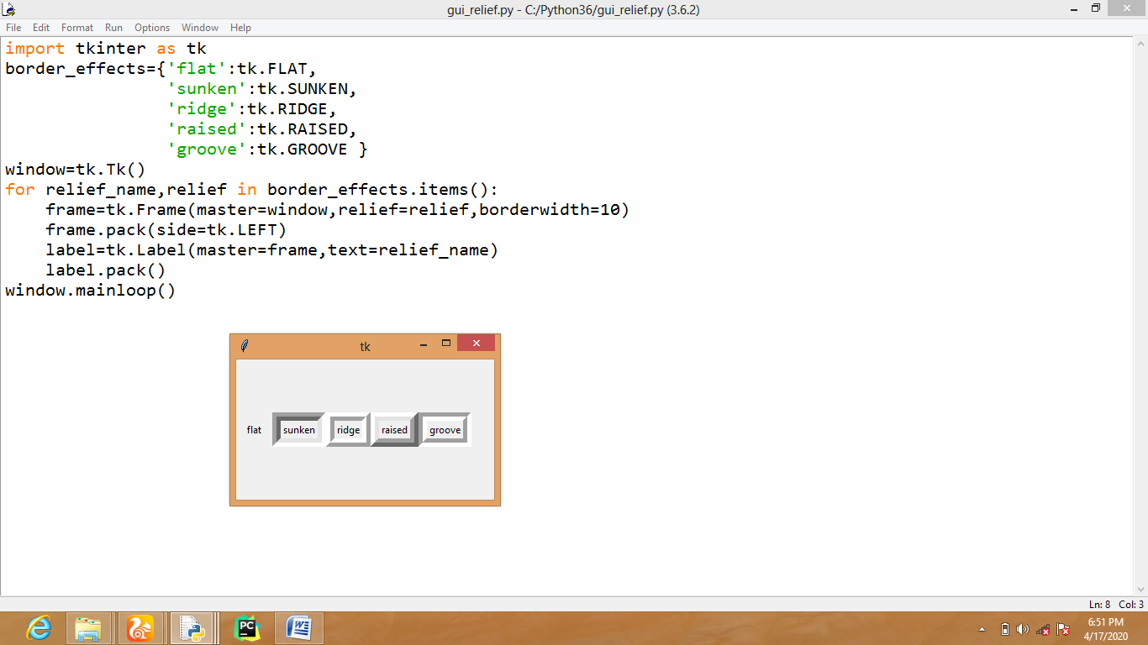
13.5 SAMPLE CODES FOR CREATING GUI
